**Assignment 4: Qualitative Research Study Proposal**

**An E-Learning Plan for Social and Emotional Learning and Academic Achievement in an Urban Charter Middle School: BASE Education**

Deniz Ismailoff

New Jersey City University

EDTC 809: Assessment and Evaluation

Dr. Christopher Carnahan

December 14, 2021

**Table of Contents**

Chapter I: Introduction……………………………………………………………………..3

Introduction………………………………………………………………………...3

Statement of the Problem………....………………………………………………..3

Purpose ................................…...…………………………………………………..4

Research Questions………………………………………………………………...6

Chapter II: Review of the Literature…………………………………………………….....7

Introduction...............................................................................................................7

The Impact of Mindfulness and Social and Emotional Learning..............................7

Student Academic Achievement...............................................................................8

Summary...................................................................................................................9

Chapter III: Methodology....................................................................................................11

Research Design.......................................................................................................11

Population and Sample Size.....................................................................................12

Instruments and Procedures......................................................................................13

Interview Questions, and Timeline..........................................................................14

Conclusion................................................................................................................15

References............................................................................................................................17

Appendices............................................................................................................................20

Appendix A: Investigators Instructional Review Board (IRB) Application.............20

Appendix B: Protocol Summary ..............................................................................28

Appendix C: CITI Certification................................................................................29

Appendix D: Survey Instrument...............................................................................30

Appendix E: Interview Questions.............................................................................34

Appendix F: Investigators Instructional Review Board (IRB) Checklist.................35

An E-Learning Plan for Social and Emotional Learning and Academic Achievement in an Urban Charter Middle School: BASE Education

**Chapter One: Introduction**

Emotional well-being is a core concern within several research disciplines, including mental health, education, and psychology. The assertion is that psychological or emotional well-being is relatively stable but not fixed (Geertshuis, 2019). Thus, psychological well-being can be affected by changes in environmental, mental, and emotional conditions over days, weeks, or months (Geertshuis, 2019). Conceptions of well-being within education have mainly focused on students' increased incidence and severity of depression and anxiety. The change in education from traditional classroom settings to online learning, now back to the classroom, elevates stress and anxiety levels. The decline in motivation and the concern for students’ mental health and well-being have developed. Thus, the prominence of integrating mindfulness practices and social-emotional learning (SEL) for students' well-being post-Covid-19 and in determining an effective educational e-learning plan is fundamental for student success. This proposal recommends supporting middle school students' well-being and increasing academic achievements by creating and implementing SEL activities and lessons through an e-learning platform: BASE Education.

**Statement of the Problem**

With student safety, physically and emotionally, and aggregating learning loss due to Covid-19, mindfulness in students' social and emotional well-being and incorporating innovative digital learning platforms have become the forefront in education. Social and emotional learning (SEL) and mindfulness are an integral part of education and human development. The Aspen Institute National Commission on Social, Emotional, and Academic Development revised what constitutes success in schools. Scientific evidence demonstrates that social, emotional, and academic development are interconnected in the learning process (Immordino-Yang et al., 2018). Mindfulness practices have also become one of the most critically essential practices followed in education during and post Covid-19. Mindfulness maintains a moment-by-moment awareness of our thoughts, emotions, bodily sensations, and surrounding environment with openness and curiosity (Browning et al., 2020). Lastly, mindfulness strategies and SEL activities and lessons can help alleviate daily stressors students experience due to Covid-19 and reduce negative thoughts and behaviors while increasing academic achievement.

With the notion of student well-being in mind, many educational companies are creating and implementing innovative digital e-learning platforms, such as CASEL, Edmentum, and BASE Education, to aid in student academia and well-being. Educators integrate these research-based practices and adapt their lessons to fit individual learners' needs, students working in groups, or implementing strategies schoolwide to foster a safe, healthy, and positive school culture and climate (Browning et al., 2020). Through implementing an e-learning plan on mindfulness and incorporating SEL activities and lessons, students can apply the knowledge, skills, and attitudes required to develop healthy identities, manage emotions, show empathy for others, maintain healthy relationships, and achieve personal and practical goals (Ergas, 2019).

**Purpose**

Horton (2012) explains e-learning as the use of electronic technologies to create learning experiences. In constructing an effective e-learning plan, design (what we do) and development (how we carry out those decisions) are involved and provide students with a wealth of information and knowledge. BASE Education is described to be an effective e-learning curriculum that inspires students to think and formulate inquiries based on their discoveries, findings, creativity, and self-expression, allowing for increased intrinsic motivation and academic development. Its digital social-emotional learning curriculum allows educators, counselors, and administrators to connect. Assigned educators can access student work, identify any immediate danger, and collaborate with students. The CASEL approved SEL and mindfulness lesson plans and activities embedded in the program can help students build rapport through evidence-based best practices while allowing educators to customize their learning experiences (BASE, 2021).

A study conducted by the pioneers of BASE Education, with the assistance of Excelsior Youth Centers, examined the impact of BASE Education on students' well-being and academia. The research indicates that 87% of students feel successful when doing BASE coursework, 71% of students reflect on BASE coursework on their own time, 77% utilize what they have learned from the program in their everyday life, and 81% of students say that BASE empowers them to discuss personal matters with their counselor that they could not before the program (BASE, 2021). The global BASE Education SEL interactive lessons and videos enable students to determine and exhibit their values, knowledge, and behavior as aligned to the topic being explored. BASE Education was created to offer students an outlet for personal growth and provide a private and safe space to share and reflect. Incorporating this therapeutic approach can encourage students to make discoveries about themselves while giving them a sense of hope for their future (Edmentum, 2021). The calming design of the program can allow for concentration while the minimal texts actively engage the brain's emotion center. The result is a non-academic look and feel to evoke optimal engagement. Its unique model offers students autonomy to share yet provides a way for educators to quickly connect with and understand their students better (Edmentum, 2021).

Given the vast challenges in the instructional day, educators rarely have the time or resources to provide every student with the one-on-one attention they deserve. This program will allow educators to understand their students deeper, hear their stories, and provide them with the individualized support they need. Research reports that students who utilized BASE Education as a part of their curriculum felt cared for and heard (Edmentum, 2021). Whether the SEL activities or lessons are utilized in group instruction or individualized support, practical and complex social and emotional and mental health lessons are presented for forward-thinking and meeting the needs of our 21st-century learners.

**Research Questions**

The research aims to investigate the relationship, if any, between the implementation of social and emotional learning (SEL) activities and lessons from BASE Education, an e-learning platform, and middle school students' well-being and academic achievement. Three research questions were created to analyze the effectiveness of the SEL lessons on improving students' well-being and academic achievement:

* RQ1: What are teacher perspectives on the social and emotional (SEL) activities and lessons on BASE Education as an instructional design for middle school students' well-being and academic achievement?
* RQ2: What are potential strengths and challenges teachers and students experience utilizing BASE Education?
* RQ3: What are the effects of the social and emotional (SEL) activities and lessons from BASE Education on students’ well-being and academic achievement?

**Chapter Two: Review of the Literature**

**Introduction**

Research regarding mindfulness and social and emotional learning in education during and post Covid-19 was required to proceed with this study. Studies regarding mindfulness and social and emotional learning (SEL) have been conducted for decades. However, the recent emphasis on mindfulness and well-being in education has increased due to stressors from Covid-19. The pandemic led to unprecedented school closures and prompted educational systems to find alternative teaching methods on a short notice. This created an innovative road map for educational technology and emphasized incorporating digital mindfulness practices and SEL to aid student well-being and academic achievement.

**The Impact of Mindfulness and Social and Emotional Learning**

  The pandemic has forced changes in traditional education which have caused families, students, and educators moderate to high levels of stress and anxiety. The wave of learning innovations, especially given the abrupt transitioning, has changed students' motivation and willingness to learn. Parents have expressed concern about the challenges of digital learning. Any technical issues with internet connection could result in a loss of instructional time (Bhamani et al., 2020). Research suggests that mindfulness-based interventions (MBIs) offer the potential for addressing a wide range of both teacher and student stressors (Wigelsworth & Quinn, 2020).

There is emerging evidence demonstrating the benefits of mindfulness for individuals of all ages in physical and mental health and education (Browning et al., 2020). Zimmerman (2018) advocates that the power of mindfulness rests because, as humans, we cannot always control our lived experiences. Thus, it is essential to practice mindfulness in our everyday lives, especially during these trying times within the education system. With this notion, many schools are implementing mindfulness and SEL into their curriculum. Mindfulness practices are complementary to SEL, as self-awareness and self-management. Studies show that SEL delivers long-term improvements in skills, behavior, and academic performance while reducing anxiety and depression. Schoolwide SEL helps students excel academically, builds stronger relationships, and leads happier, healthier, more fulfilling lives (Browning et al., 2020).

The Collaborative for Academic, Social, and Emotional Learning (CASEL) promotes SEL as a critical element to students' academic, social, personal, and professional success. CASEL addresses five broad and interrelated areas of competence and highlights. Examples of each are self-awareness, self-management, social awareness, relationship skills, and responsible decision-making. These competencies can be taught and applied at various developmental stages from childhood to adulthood and across diverse cultural contexts (CASEL, 2021). Additionally, SEL provides authentic school-family-community partnerships to establish learning environments and experiences that feature trusting and collaborative relationships, rigorous and meaningful curriculum and instruction, and ongoing evaluation (CASEL, 2021). Lastly, SEL can help address various forms of inequity, empower creativity in schools, and contribute to safe, healthy, and just communities (Browning et al., 2020). Many education systems globally utilize mindfulness practices and SEL in their curriculum to increase academic achievements, aid in school engagement, focus on health and wellness and fulfill interpersonal goals (Ergas, 2019).

**Student Academic Achievement**

There are many potential contributing factors to personal anxiety towards learning. However, the shift from traditional in-class education to remote learning and back to the classroom still requires further evaluation. However, mindfulness practices have been frequently associated with stress relief and improvement in academic achievement. The Center on Reinventing Public Education (CRPE) (2020) explains that education will suffer without face-to-face interactions among students and teachers. Nevertheless, educators delivered instruction—including new content—as effectively as possible under unprecedented circumstances. Some district leaders set a grading policy that limited how much students' grades could drop during the school closure. Some middle school students would retain their third-quarter grade if they showed competency in the final quarter (CRPE, 2020). If students failed to show competency, their grades would only be reduced by one level. Some districts launched formal instruction but avoided real-time teaching. School districts aspired to make remote instruction more manageable for teachers, many of whom had children at home, and maximize flexibility for parents and students. Depending on the district, teachers were provided additional time to prepare for their online classes (CRPE, 2020). However, regardless of the district, school systems worked closely with families to ensure the safety and best possible education for all students.

**Summary**

Research on mindfulness-based instruction and social and emotional learning (SEL) e-learning platforms have steadily grown in schools and has documented a promising approach in education to support students' well-being and academic achievement during and post Covid-19 (Browning et al., 2020). SEL helps students practice personal mindfulness for self-care, engaging in conscious transformation, and establishing a school culture of safety, respect, and rapport (Ergas, 2019). Several successful mindful SEL practices were implemented in school districts, such as breathing techniques, monthly mental health newsletters, and implementing digital e-learning platforms to create and promote mindfulness in education and devise a healthy daily routine (CASEL, 2021).

Other notions related to mindfulness were the intentionality, acceptance, and value of mindfulness practices. However, the strategies implemented varied based on the school district. School districts have reached out to ensure that families had their basic needs met and students held the tools required to learn. Schools also focused on building centralized units of study, which reduces the burden on teachers who are expected to deliver instruction differently, and the potential for variation across teachers and schools (Husne & Oznacar, 2021). This helped district leaders ensure that all students were ready for instruction regardless of their residency. Finally, differentiated digital e-learning platforms were provided in school districts to maximize the effect of mindfulness and SEL practices for all students' well-being and academic achievement.

**Chapter Three: Methodology**

**Introduction**

The researcher will conduct a qualitative descriptive research design to investigate the relationship between implementing social and emotional learning (SEL) activities and lessons from BASE Education, an e-learning platform, and charter middle school students' well-being and academic achievement. The researcher's methodological framework, procedures, and rationale will be conducted to study the strengths and weaknesses of BASE Education in supporting well-being and academic achievement. Unlike quantitative research, phenomenology provides insights into a group's lived experiences or person (Merriam & Tisdell, 2015). Social phenomenon and participants' reflections are the focal points in qualitative research, marking this approach most appropriate to address the research questions (Creswell & Creswell, 2018). Both teachers and students’ perceptions on the e-learning platform will take account for data collection. This will be achieved by evaluating both the process and outcome of Base Education, an e-learning SEL platform. Data will be collected through survey responses, interview responses to open-ended questions, and academic achievement will be gauged by reviewing student grades pre and post implementation of Base Education in an urban charter middle school in Passaic, New Jersey. As the perception described by the participants is based on their account, the qualitative approach will most successfully explain the "how" of each research question (Morse, 2015).

**Research Design**

Qualitative research encourages exploring the phenomena when participants are observed in their natural environment (Torres & Oluwole, 2015). From this methodology, themes and trends will emerge from implementing social and emotional activities and lessons from BASE Education and students' well-being and academic achievement. This qualitative descriptive research design provides a detailed explanation of the phenomenon disclosed by employing an informed consent survey to recruit participants and open-ended interview questions to both teachers and students that utilized the e-learning platform. Utilizing semi-structured interviews relating to the research questions will produce the desired data. Sohn et al. (2017) emphasize the importance of understanding the participants' experiences from their perceived interpretations. As such, a qualitative descriptive approach is most appropriate for this study, unlike quantitative research that addresses statistical or numerical data analysis (Yin, 2018).

**Population and Sample Size**

The BASE Education e-learning platform is approved by The Collaborative for Academic, Social, and Emotional Learning (CASEL) and is designed to provide educators with the tools necessary to teach and reinforce social and emotional learning (SEL) concepts such as empathy, compassion, and mindfulness to students (CASEL, 2021). The e-learning platform also will empower students to control their emotions and behaviors, improve relationship skills and social awareness, and exercise critical decision-making to plan for their futures (Edmentum, 2021). The target population selected for this proposed study includes teachers and students that utilized the e-learning platform Based Education to support well-being and academic achievement in an urban charter middle school located in Passaic, New Jersey. Based on an analysis of the charter middle school, there are approximately 38 observable teachers, 63 staff members, and 460 students from grades four to eight. Each teacher, student, and parent/guardian (to gain consent for minors) will be individually emailed regarding the study with a link to the Qualtrics survey. According to the Qualtrics responses for participation from teachers, parents/guardians, and students, the sample size for the study will be determined. The study will include teachers willing to participate in the study and students from the urban charter middle school who felt anxiety due to the COVID-19 pandemic that utilized the BASE Education e-learning platform upon returning to in-person learning.

**Instruments, Procedures, and Resources**

New Jersey City University first acquires initial approval for the researcher's study from the Institutional Review Board (IRB) "Appendix A." When IRB approval is received, site authorization from the charter middle school is required. In addition, a consent form survey questionnaire will be emailed to teachers, parents/guardians, and students for permission to participate in the research study "Appendix D." Participants will be informed of their right to terminate participating in the research study. Once informed consents are collected, the research will begin. Informed consent reports will be utilized to abide by the ethical standards to protect the study participants' rights and well-being (Koç & Fidan, 2020). The researcher will ensure confidentiality and that there are no personal ties to the participants. All conducted interviews will take place in the participants' natural environment (school building).

The instruments utilized in this research study are a survey constructed in and distributed via Qualtrics and individual in person semi-structured open-ended interviews. The participating students’ grades will be analyzed prior to the implementation of BASE Education and after the program’s usage. The limitation of getting an adequate sample size for the research study is that participation must be approved at many levels, from the school district level to parental approval, since the majority of the participants are secondary students. The resources utilized during the interviews will include a voice recorder, notebook, and a question guide to help write responses corresponding to the participants' inquired questions. The researcher will travel to the charter middle school to conduct interviews with teachers and students. The study will conclude after the ending of one full marking period. This is approximately four months. The findings from this research study will add to the literature by addressing the charter middle school teachers' and students' responses to the SEL activities and lessons from the e-learning platform BASE Education. The findings will answer if the program aided in students' well-being and academic achievement.

**Interview Questions and Timeline**

The interviews will comprise of the following questions:

Teacher Questions

1. What are your thoughts or experiences with transitioning from online, hybrid, to in-person learning?
2. How effective do you think BASE Education was for your students' well-being and academic achievement? Follow up: Why?
3. What were the strengths and weaknesses of the BASE Education program?
4. Would you recommend BASE Education to other school districts? Grade levels? Follow up: Why?

Student Questions:

1. What are your thoughts or experiences with transitioning from online, hybrid, to in-person learning?
2. Has your school or teachers helped you with transitioning back to the classroom? Follow up: How? If not, what kind of help would you have liked to receive?
3. Has your well-being improved since the implementation of BASE Education? Follow up: How? If not, what do you think would have been helpful?
4. Have you seen a difference in your grades since you started BASE Education? If not, what do you think would have been helpful?

**Timeline for Research Study**

|  |  |  |  |  |
| --- | --- | --- | --- | --- |
|  | **July/August** | **September** | **October** | **November/December** |
| Week 1 | -Background research  -Initial approval for the researcher's study from NJCU  -Site authorization from the charter middle school | -Observations of BASE Education SEL activities and lessons from the urban charter middle school | -Continue teacher interviews  -Begin setting interviews with students | -Organize collected data  -Data analysis |
| Week 2 | -Send out informed consent form to teachers, students, and parents in the charter middle school about the research study and approval to participate | -Observations of BASE Education SEL activities and lessons from the urban charter middle school | -Continue observations, and teacher and student interviews from the urban charter middle school | -Data analysis  -Begin writing final report draft |
| Week 3 | -Collect informed consents  -Identify research participants | -Observations of BASE Education SEL activities and lessons from the urban charter middle school | -Continue observations, and teacher and student interviews from the urban charter middle school | -Final report draft |
| Week 4 | -Observations of BASE Education SEL activities and lessons at the urban charter middle school | -Observations of BASE Education SEL activities and lessons. Begin teacher interviews | -Collect and organize data | -Final report |

**Conclusion**

While academia is vital for student success, well-being and mental health are the core to motivation and engagement (Geertshuis, 2019). Decades of research demonstrate that education promoting social and emotional learning (SEL) achieves positive results. The findings are congregated from multiple fields of sources, including student achievement, neuroscience, health, counseling, classroom management, and the prevention of negative behavior (Ergas, 2019). While there are many potential contributing factors to personal anxiety towards learning, a shift from traditional classroom settings to online learning, now back to the classroom, requires mindfulness practices, frequently associated with stress relief and improvement in academic achievement (Ergas, 2019).

With this notion in mind, the research proposal aims to utilize BASE Education, an e-learning platform approved by The Collaborative for Academic, Social, and Emotional Learning (CASEL). The BASE Education platform will present students and educators in a urban charter middle school in Passaic, New Jersey with various SEL activities, impactful SEL skills, and lessons on coping strategies, digital citizenship, bullying, and equity. The e-learning platform will signify BASE Education as the digital program that empowers students to regulate their emotions and behaviors, develop relationship skills and social awareness, and exercise critical decision-making to plan for their futures (Edmentum, 2021). Lastly, the researcher will examine the collected data and utilize it to assess the continuation of the e-learning SEL program for the rest of the school year with a possibility of program expansion to the urban elementary and high charter schools in Passaic, New Jersey for the 2023-2024 fiscal school year.

**References**

Acharya, A., Prakash, A., Saxena, P., & Nigam, A. (2013). Sampling: Why and how of it? *Indian Journal of Medical Specialties*. doi:10.7713/ijms.2013.0032.

BASE Education. (2021). Why base education? Your students are ready to be heard. Retrieved from: <https://base.education/>.

Bhamani, S., Makhdoom, A. Z., Bharuchi, V., Ali, N., Kaleem, S., & Ahmed, D. (2020). Home learning in times of covid-19: Experiences of parents. *Journal of Education and Educational Development, 7*(1), 9–26.

Browning, A., Romer, N., WestEd, & California Department of Education. (2020). Mindfulness-based practices for schools. In WestEd.

CASEL (2021). A Guide to schoolwide SEL. Retrieved from. <https://schoolguide.casel.org/>.

Center on Reinventing Public Education (CRPE). (2020). Keeping learning on track in a crisis: Lessons from roaring fork school district’s covid-19 response spring 2020. *In Center on Reinventing Public Education*. Center on Reinventing Public Education.

Clark, R., C. & Mayer, E. R. (2016). E-learning and the science of instruction: Proven guidelines for consumers and designers of multimedia learning (4th ed.). Wiley & sons.

Creswell, J. W., & Creswell, J. D. (2018). Research design: qualitative, quantitative, and mixed methods approaches. (5th ed.). SAGE.

Edmentum. (2021). Base education*.* *Edmentum International.* Education City. Retrieved from: <https://www.edmentuminternational.com/base-education/>.

Ergas, O. (2019). Mindfulness in, as and of education: Three roles of mindfulness in education.*Journal of Philosophy of Education, 53*(2), 340–358.

Geertshuis, S. A. (2019) Slaves to our emotions: Examining the predictive relationship between emotional wellbeing and academic outcomes. *Active Learning in Higher Education, 20*(2), 153-166. <https://doi.org/10.1177/1469787418808932>.

Horton, W. (2012). E-learning by design (2nd ed., p. 1). Wiley & sons. Pfeiffer.

Hüsne M. S., Oznacar, B. (2021). Effects of Covid-19 period on educational systems and institutions. *International Journal of Curriculum and Instruction, 13*(1) 37-551. <http://ijci.wcci-international.org>.

Immordino-Yang, M. H., Darling-Hammond, L., Krone, C., & Aspen Institute, N. C. on S. E. & A. D. (NCSEAD). (2018). The brain basis for integrated social, emotional, and academic development: How emotions and social relationships drive learning. *In Aspen Institute*. Aspen Institute.

Koç, M. H., & Fidan, T. (2020). The institutionalization of ethics in schools: A Qualitative research on teachers. *Participatory Educational Research, 7*(2), 80–101. Retrieved from: <https://files.eric.ed.gov/fulltext/EJ1255552.pdf>.

Merriam, S. B., & Tisdell, E. J. (2015). Qualitative research: A guide to design and implementation. John Wiley & Sons.

Morse, J. M. (2015). Critical analysis for determining rigor in qualitative inquiry. *Qualitative Health Research, 25*(9), 1212-122. [doi.org/10.1177/1049732315588501](https://doi.org/10.1177%2F1049732315588501).

Roulston, K., & Choi, M. (2018). Qualitative interviews. The SAGE handbook of qualitative data collection, 233-249.

Sohn, B. K., Thomas, S. P., Greenberg, K. H., & Pollio, H. R. (2017). Hearing the voices of students and teachers: A phenomenological approach to educational research. *Qualitative Research in Education, 6*(2), 121-148. Retrieved from <https://files.eric.ed.gov/fulltext/EJ1150987.pdf>.

Torres, A. C., & Oluwole, J. (2015). Teacher satisfaction and turnover in charter schools: examining the variations and possibilities for collective bargaining in state laws.*Journal of School Choice, 9*(4), 503–528. doi: 10.1080/15582159.2015.1079468.

Wigelsworth, M., & Quinn, A. (2020) Mindfulness in schools: an exploration of teachers’ perceptions of mindfulness-based interventions. *Pastoral Care in Education, 38* (4), 293-310. https://doi: [10.1080/02643944.2020.1725908](https://doi.org/10.1080/02643944.2020.1725908).

Yin, R. K. (2018). Case study research and applications: Design and methods (6th ed.). Sage.

Zimmerman, A. (2018). Considering the prospect of cultivating mindfulness in teacher education. *Issues in Teacher Education, 27*(1), 57–72.

Appendix A

IRB Application

**NJCU Institutional Review Board Application for   
Review of Research Project**

Email all materials in one file to: [IRB@njcu.edu](mailto:IRB@njcu.edu)

and [kresch@njcu.edu](mailto:kresch@njcu.edu)

|  |  |
| --- | --- |
| **FOR OFFICE USE ONLY- Please do not provide any information in this box.** | |
| Date Complete Application Submitted |  |
| Review Type |  |
| Principal Investigator* |  |

* **For all student research, the faculty advisor is the Principal Investigator**.

**Date of Submission**: December 13, 2021

**Name of PI/Sponsor Submitting Application**:

**Application Type**: 🗹 Original   ◻ Previously Approved

|  |  |
| --- | --- |
| Proposal Title | An E-Learning Plan for Social and Emotional Learning and Academic Achievement in an Urban Charter Middle School: BASE Education |
| Proposed Start Date | August 2022 |
| Anticipated Duration of Research | 5 months (August- December) |
| CITI Certification by all researchers | #45750531 |

**Type of Research**

🗹 Student/Classroom project

◻ Faculty research project

◻ Staff research project

◻ External researcher project (All external researchers must have an NJCU faculty/staff sponsor)

**NJCU Investigators** (Please list additional investigators as necessary)

Name: Dr. Christopher Carnahan

Department: Educational Technology Leadership

Telephone Number: 201-200-2547

Email Address: ccarnahan@njcu.edu

**Co-Investigator** (including student researchers)

Name: Deniz Ismailoff

Department: Educational Technology Leadership

Telephone Number: 551-206-5689

Email Address: dismailoff@njcu.edu

**Co-Investigator** (including student researchers)

Name:

Department:

Telephone Number:

Email Address:

**Co-Investigator** (including student researchers)

Name:

Department:

Telephone Number:

Email Address:

* Any NJCU investigator who plans to work on this project either with or for a Principal Investigator or Co-Investigator at any other institution must identify those investigators and their institutions below.

**External Investigators**

Name:

Department:

Telephone Number:

Email Address:

Name:

Department:

Telephone Number:

Email Address:

Name:

Department:

Telephone Number:

Email Address:

Name:

Department:

Telephone Number:

Email Address:

**NJCU Sponsor** (if the researcher is not affiliated with NJCU)

Name:

Department:

Telephone Number:

Email Address:

1.Number of participants: Approximately 38 observable teachers, 63 staff members, and 460 students from grades four to eight. Each teacher, student, and parent/guardian (to gain consent for minors) will be individually emailed regarding the study with a link to the Qualtrics survey.

2. How was this number determined (e.g., power analysis)? According to the Qualtrics responses for participation from teachers, parents/guardians, and students, the sample size for the study will be determined.

3. Does this project require the collection of new data? 🗹 Yes ◻ No

3A. If yes, how will participants be selected or recruited? (<4-5 sentences)?

|  |
| --- |
| Each teacher, student, and parent/guardian (to gain consent for minors) will be individually emailed regarding the study with a link to the Qualtrics survey. The study will include teachers willing to participate in the study and students from the urban charter middle school who felt anxiety due to the COVID-19 pandemic that utilized the BASE Education e-learning platform upon returning to in-person learning. |

3B. Will subjects participate on a fully voluntary basis? 🗹 Yes ◻ No

3C. Will subjects be compensated for their participation? ◻ Yes 🗹 No

3D. If yes, please briefly describe the compensation.

|  |
| --- |
|  |

4. Does this project make use of human tissue or cell lines? ◻ Yes 🗹 No

5. Briefly describe the research methodology(ies) to be used in this study (e.g., focus group, participant observation

|  |
| --- |
| The proposed survey is a qualitative descriptive research design to investigate the relationship between implementing social and emotional learning (SEL) activities and lessons from BASE Education, an e-learning platform, and charter middle school students' well-being and academic achievement. The researcher's methodological framework, procedures, and rationale will be conducted to study the strengths and weaknesses of BASE Education in supporting well-being and academic achievement. This will be achieved by evaluating both the process and outcome of Base Education, an e-learning SEL platform. Data will be collected through survey responses, interview responses to open-ended questions, and academic achievement will be gauged by reviewing student grades pre and post implementation of Base Education in an urban charter middle school in Passaic, New Jersey. |

6. Does this project use data that have already been collected for a non-research purpose or by another researcher? ◻ Yes 🗹 No

6a. If yes, what is the source of the data? (3-4 sentences)

|  |
| --- |
|  |

6b. Are the data accessible in the public domain? ◻ Yes 🗹 No

6c. If no, does the data include information that would allow the identification of individuals, either directly or indirectly? ◻ Yes 🗹 No

6d. If yes, please explain briefly how participant confidentiality will be safeguarded (3-4 sentences).

|  |
| --- |
|  |

**Participant Risks**

7. Will participants be exposed to any stresses (e.g., anxiety, pain, etc.) or physical harm (e.g., injury, infection, etc.) in connection with this research?  ◻ Yes 🗹 No

7a. If yes, please briefly explain what risks may be involved in the research, what specific steps will be taken to minimize and monitor the risk, and what will be done to compensate and/or treat participants who are harmed by the research? (4-5 sentences).

|  |
| --- |
|  |

8. Does the research design require that participants be deceived? ◻ Yes 🗹 No

8a. If yes, please briefly explain why deception is necessary and what steps will be taken to reduce potential harm from this deception. (<3-5 sentence)

|  |
| --- |
|  |

**Potentially Vulnerable**

9. Human Research Subject Populations- Please check if your research involves vulnerable populations:

Physically/Mentally Challenged Individuals: ◻ Yes 🗹 No

Young Children (ages 0-13): 🗹 Yes ◻No

Older Children (ages 14-17): 🗹 Yes ◻ No

Senior Citizens (over age 65): ◻ Yes 🗹 No

Pregnant women ◻ Yes 🗹 No

Prisoners ◻ Yes 🗹 No

9a. If any in Question #9 is checked **yes**, please briefly explain how the rights of this (these) population(s) will be protected. (<4-5 sentences)

|  |
| --- |
| Each teacher, student, and parent/guardian (to gain consent for minors) in grades 4-8 will be individually emailed regarding the study with a link to the Qualtrics survey. The study will include teachers willing to participate in the study and students from the urban charter middle school who felt anxiety due to the COVID-19 pandemic that utilized the BASE Education e-learning platform upon returning to in-person learning. |

**Informed Consent** (Please attach your informed consent form(s)).

10. Consent forms must contain the following in lay terms:

The voluntary nature of their participation and the freedom to withdraw  
without penalty at any time: 🗹 Yes ◻ No

The purposes and procedures of the research: 🗹 Yes ◻ No

Any reasonably foreseeable risk or discomfort: 🗹 Yes ◻ No

Any benefits to them or to others from the research: 🗹 Yes ◻ No

The extent to which confidentiality will be maintained 🗹 Yes ◻ No

Whom to contact for information about the research participants’   
rights and any research-related injury 🗹 Yes ◻ No

10a. If the answer to anything in Question 10 was checked no, please briefly explain why the research requires an alteration of the standard elements of informed consent.

|  |
| --- |
|  |

11. How will participants’ informed consent be documented? Please check all that apply.

◻ Signature on a written consent document

◻ Signature on a document to be read by participants and witnessed by another party

◻ E-signature on an electronic form/survey

🗹 Written documentation of informed consent will not be obtained because of one or more

of the following criteria is satisfied

🗹 The only link between the subject and the research would be the informed

consent documentation and the primary risk is loss of confidentiality

🗹 The risks to participate, including risks associated with loss of privacy,

no greater than those ordinarily encountered in daily life and the research

involves no procedure for which written consent is normally required

outside of the research context

12. Who will obtain the informed consent of the participants?

◻ Principal Investigator

🗹 Co-Investigator

◻ Sponsor (in cases where the Principal Investigator is not affiliated with NJCU)

◻ Other

◻ Not Applicable

13. Please include your protocol summary (5-page maximum) for your recruitment materials (as applicable). You are provided a space to do so at the end of this application. Please see *Appendix* . *Protocol Summary*.

**External Funding**

14. Has this protocol been reviewed by an Institutional Review Board or Human Subjects Review Committee at any other institutions? ◻ Yes 🗹 No

If yes, at what institution(s)?

|  |
| --- |
|  |

15. What is its status? ◻ Approved ◻ Rejected ◻ Pending (or

provisionally approved)

16. Has this protocol been submitted for federal funding? ◻ Yes 🗹 No

16a. If yes, list the agency and organization.

|  |
| --- |
|  |

Submission Date:

Funding Start Date: ◻ Anticipated ◻ Actual

Contact Person:

Contact’s Telephone Number:

17. Has this protocol been submitted for any other type of funding? ◻ Yes 🗹 No

17a. If yes, list the agency or organization.

|  |
| --- |
|  |

Submission Date:

Funding Start Date: ◻ Anticipated ◻ Actual

Contact Person:

Contact’s Telephone Number:

**Proof of CIT Certification**

Please provide documentation of current CITI certification in human subjects research for **all** researchers involved in this project.

**Certificate of Agreement**

**The signatures* of all researchers involved in this project must be provided**.

I/We certify that I/we agree to comply with the requirements of both NJCU and the Office for Human Research Protection (OHRP) of the United States Department of Health and Human Services as described in 45 CFR §46.

____________________________________________ ______________________

PI Signature           Date

|  |  |  |
| --- | --- | --- |
|  |  | 12/13/2021 |

Co-PI Signature           Date

____________________________________________ ______________________

Co-PI Signature           Date

____________________________________________ ______________________

Co-PI Signature           Date

____________________________________________ ______________________

Co-PI Signature           Date

Please submit the completed application, checklist, and accompanying documents as one document or PDF file to [IRB@njcu.edu](mailto:IRB@njcu.edu) and [kresch@njcu.edu](mailto:kresch@njcu.edu)

**All applications must be submitted by the NJCU faculty or staff member serving as the Principal Investigator. Neither students nor external researchers may submit an application**.

Appendix B

Protocol Summary

The research aims to investigate the relationship, if any, between the implementation of social and emotional learning (SEL) activities and lessons from BASE Education, an e-learning platform, and middle school students' well-being and academic achievement. Three research questions were created to analyze the effectiveness of the SEL lessons on improving students' well-being and academic achievement:

* **RQ1:** What are teacher perspectives on the social and emotional (SEL) activities and lessons on BASE Education as an instructional design for middle school students' well-being and academic achievement?
* **RQ2:** What are potential strengths and challenges teachers and students experience utilizing BASE Education?
* **RQ3:** What are the effects of the social and emotional (SEL) activities and lessons from BASE Education on students’ well-being and academic achievement?

Appendix C

NJCU CITI Certificate

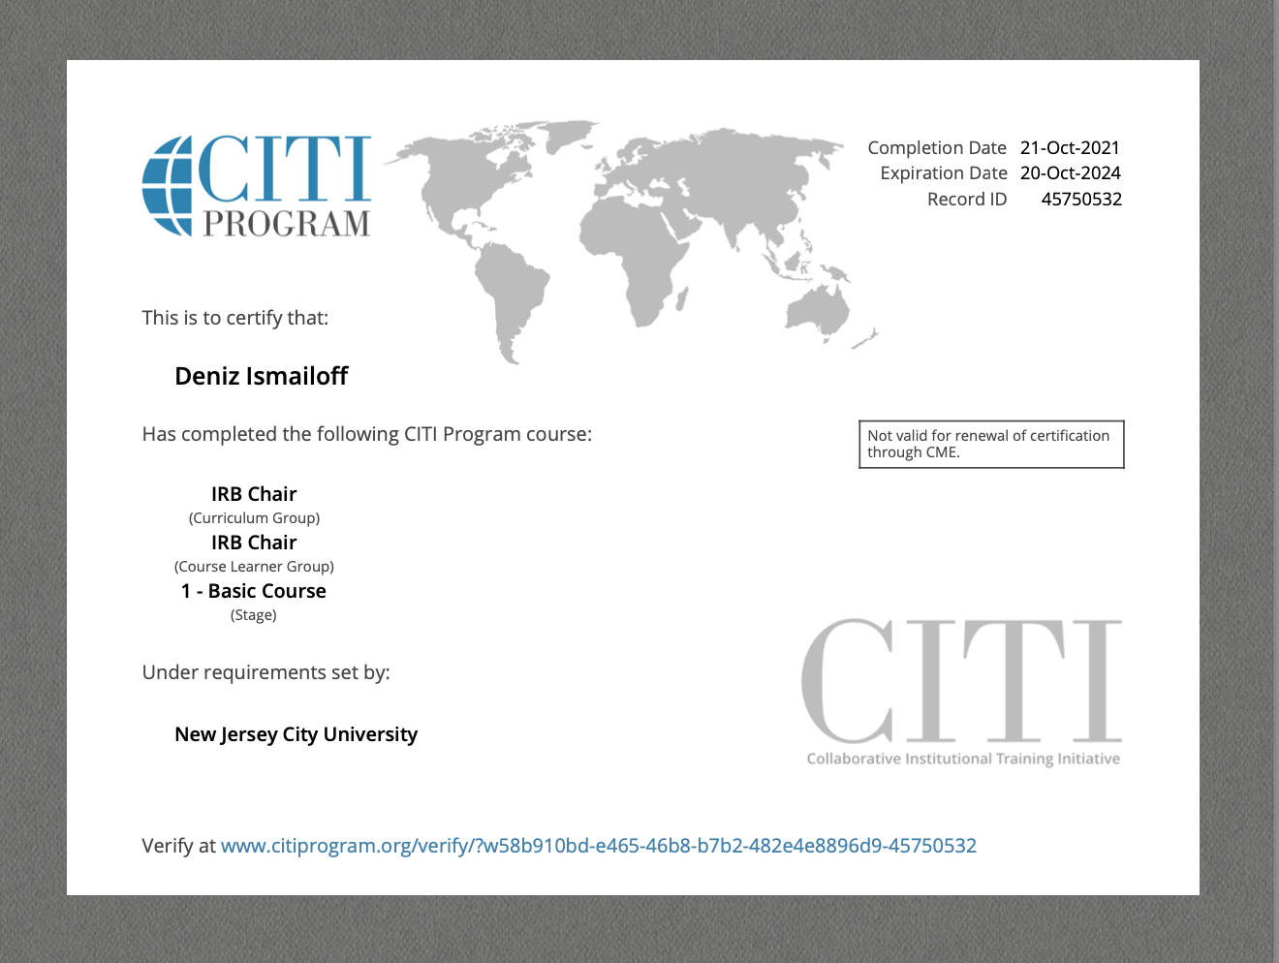

Appendix D

Survey Instrument

The published version of this survey is available at the following link:

<https://njcu.co1.qualtrics.com/jfe/form/SV_eepQBtLaLBRZ2PI>

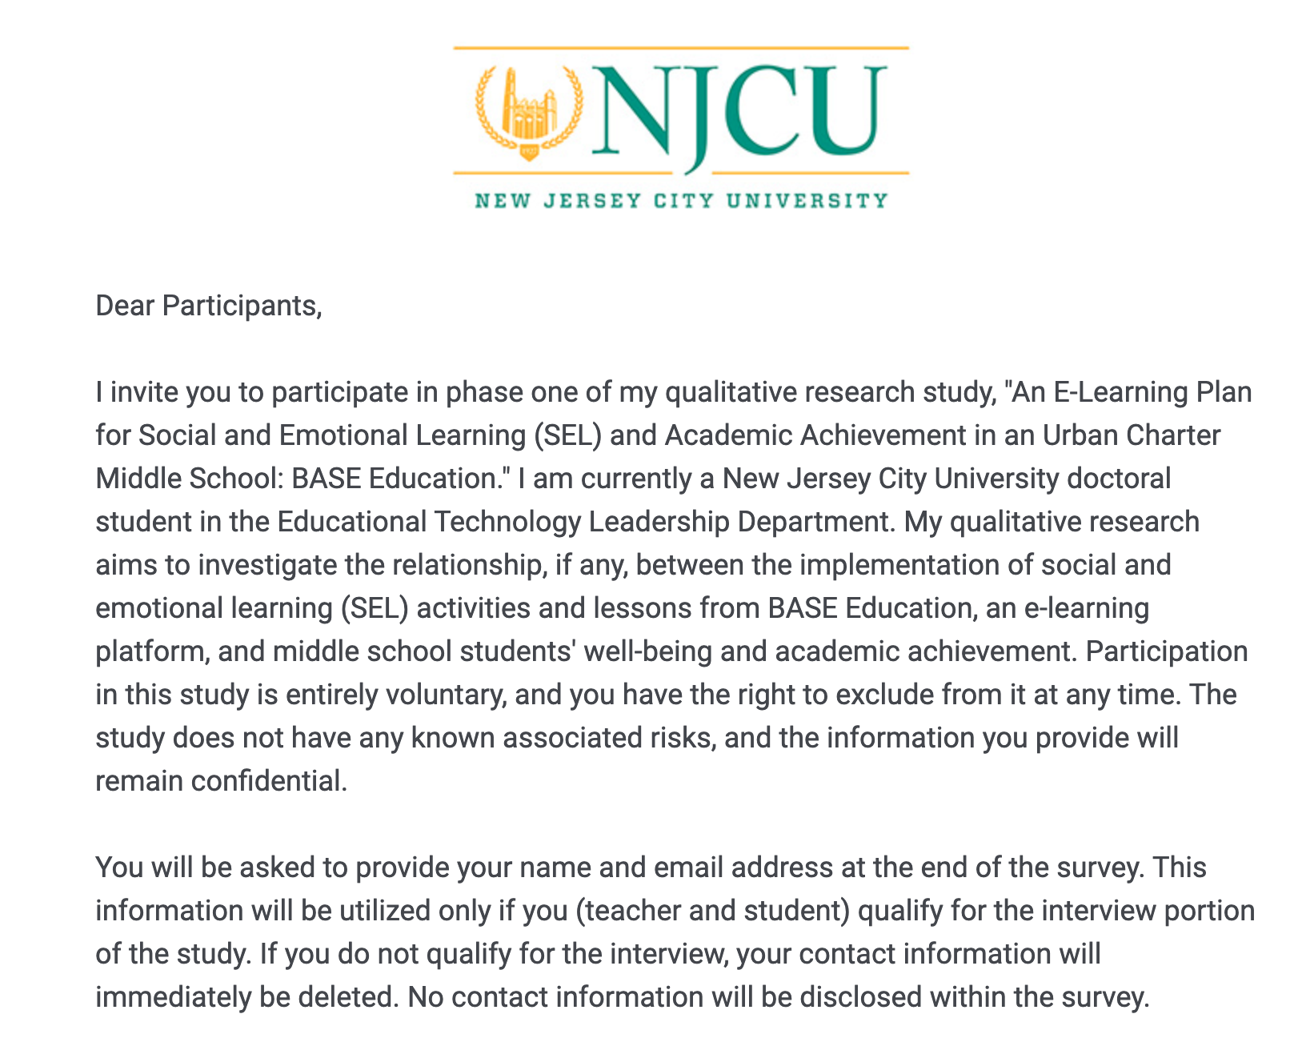

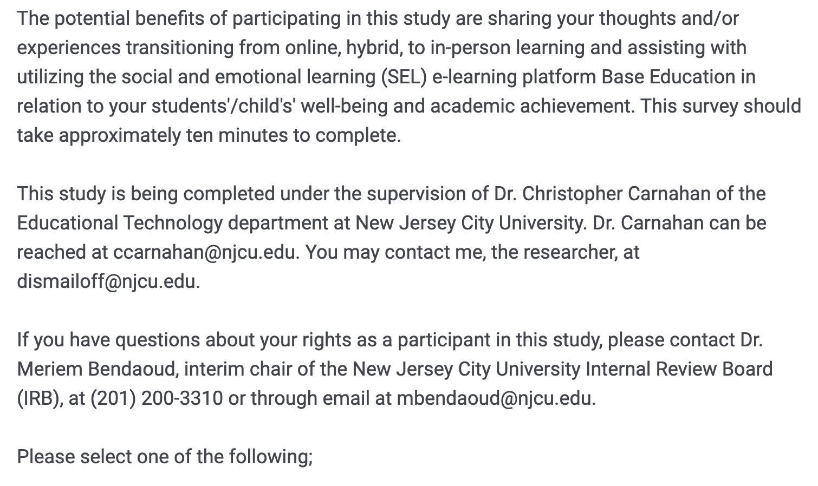

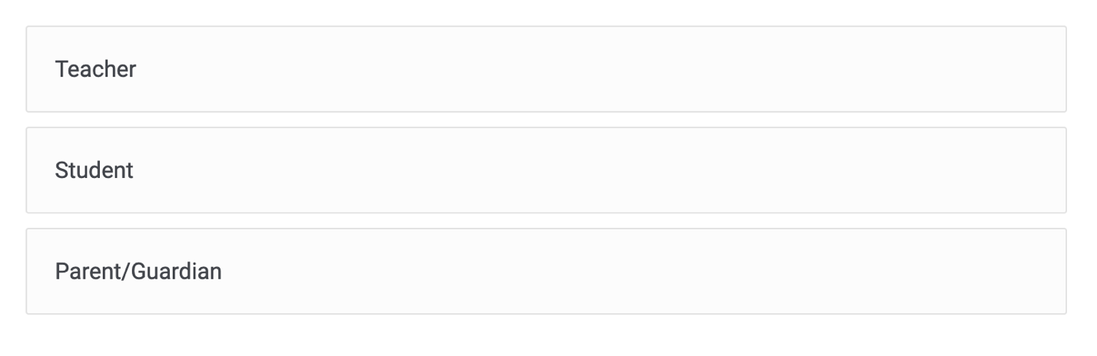

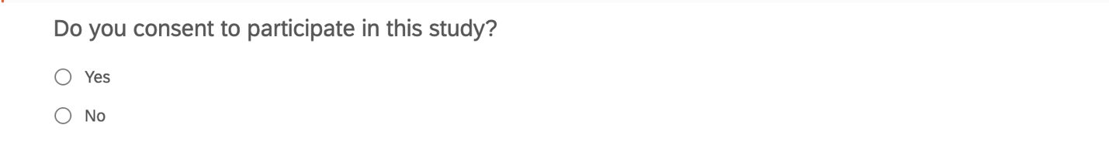**If teacher**:

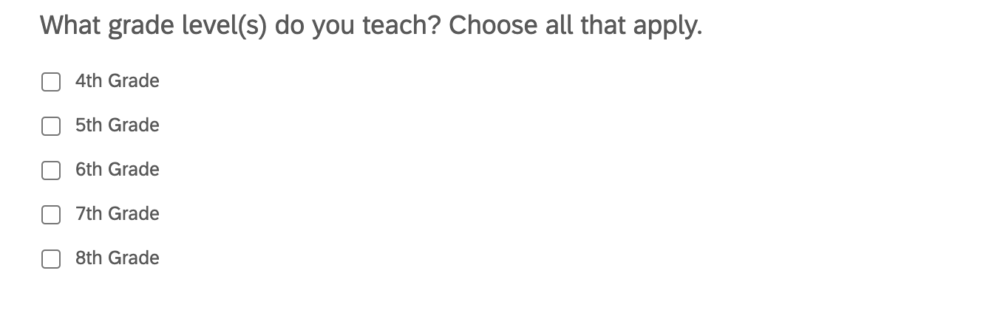

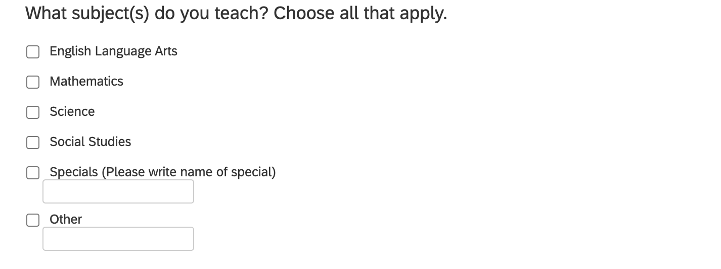

**If student:**



If parent:

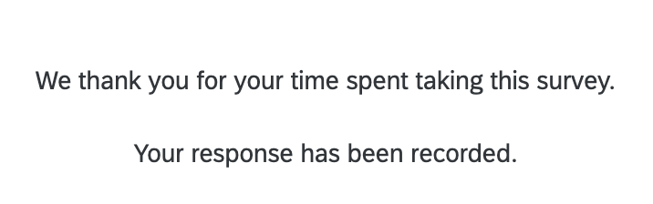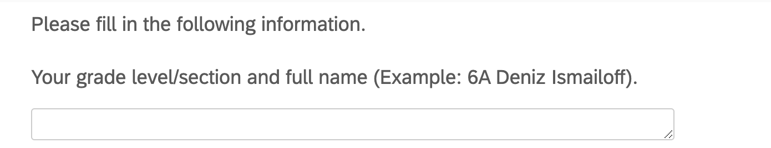

**If parent:**

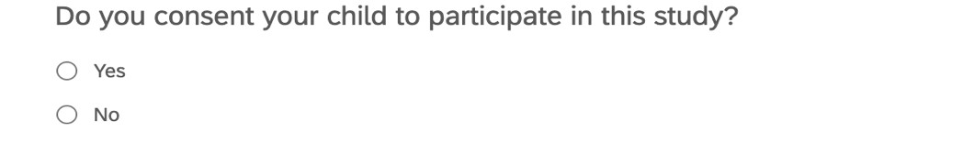

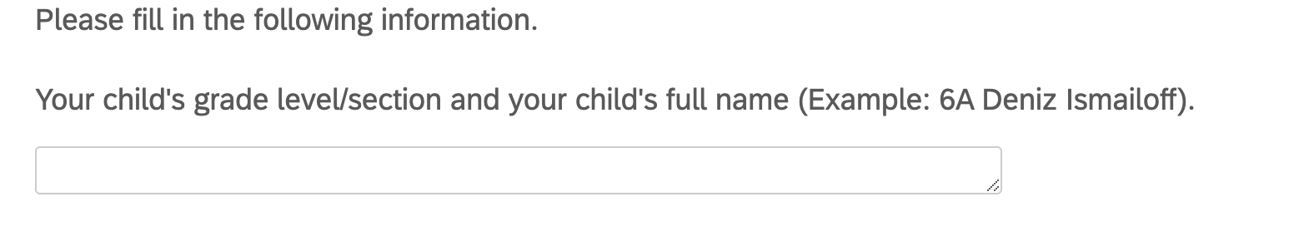

Appendix E

Interview Questions

The interviews will comprise of the following questions:

Teacher Questions

1. What are your thoughts or experiences with transitioning from online, hybrid, to in-person learning?
2. How effective do you think BASE Education was for your students' well-being and academic achievement? Follow up: Why?
3. What were the strengths and weaknesses of the BASE Education program?
4. Would you recommend BASE Education to other school districts? Grade levels? Follow up: Why?

Student Questions

1. What are your thoughts or experiences with transitioning from online, hybrid, to in-person learning?
2. Has your school or teachers helped you with transitioning back to the classroom? Follow up: How? If not, what kind of help would you have liked to receive?
3. Has your well-being improved since the implementation of BASE Education? Follow up: How? If not, what do you think would have been helpful?
4. Have you seen a difference in your grades since you started BASE Education? If not, what do you think would have been helpful?

Appendix F

IRB Application Checklist

NJCU Institutional Review Board

Email: IRB@njcu.edu

**Investigator’s Checklist for IRB Submission**

Please make sure that your file name contains your full name. Please make sure that your application is complete prior to submitting it to the NJCU IRB. Please be certain that your consent form (or procedure) includes all of the information listed below.

All applications must be submitted by the NJCU faculty or staff member who is serving as the Principal Investigator (PI). Neither students nor external researchers may submit an application. (For all students, a faculty member must serve as the PI; all external researchers must have an NJCU faculty sponsor.)

Submit the completed application and accompanying documents as one document or pdf to IRB@njcu.edu and kresch@njcu.edu. All emailed applications must be received a minimum of four weeks prior to starting your research investigation. Final approval will not be granted before receipt of all required documents.

**Application**

☑ Completed and signed Proposal Submission Form

☑ Protocol Summary (5-page limit) that identifies the research question and describes methods

☑ A list of data collection instruments that coincides with the study described in the Protocol Summary

☑ Recruitment materials (as applicable)

☑ Consent document(s) or the rationale for deviation from written consent

☑ Certificate of training in protection of human subjects from the National Institutes of Health (NIH)

☑ All Consent Form(s) are written for a general audience; are specific to subjects (and/or their parents/guardians); identify the researcher, the researcher’s position, and his/her institution; and:

☑ Describe the study and the procedures (activities, duration, and/or audio, photographic, or videotaping*) in lay terms

☑ Clearly state that there are no benefits or known risks or clearly explain the precautions that will be taken if there are risks (Monetary payment does not constitute a benefit.)

☑ Include a statement that participation is voluntary and that all subjects have the right to skip any questions or activities and to opt out at any time without penalty

☑ Provide the names of all contact persons for the study, including the Principal Investigator and, for external researchers, the NJCU sponsor

☑ Include this statement: “If you have questions about your rights as a participant in this study, you may contact Dr. Ashok Vaseashta, chair of the NJCU IRB, at (201)200-2453 or avaseashta@njcu.edu.

☑ Include a statement of confidentiality**

☑ Have places for signatures and the date.

** If the research project is planned to deviate from complete anonymity, the researcher may include a waiver to use the names of respondents, but the researcher must specify how all data will be used.

* Furthermore, for any study using audio, photographic, or video recordings, the researcher must also completely explain the use of these recordings, the plan for their storage, and if and how this information will be disseminated.