**Assessment 3: Design of an Online Community for Mindfulness and SEL Through E-Learning**

Accessible at: <https://www.facebook.com/groups/380831573920068/>

Linked to the Website: <https://mindfulnessduringcovid19.com/>

Deniz Ismailoff & Filiz Zeybek-Guven

New Jersey City University

EDTC 816: Advanced Building Online Communities

Dr. Laura Zieger

April 24, 2022

**Introduction**

The pandemic has created unknown stressors for students, parents, and educators, causing anxiety, depression, and decreased motivation and social skills (Yasmin et al., 2020). Being mindful in education during and post-Covid 19 is essential. "Mindfulness and SEL Through E-Learning" is an online community that concentrates on mindfulness and implementing social and emotional learning (SEL) through e-learning to support educators, students, and parents with innovative strategies and practical resources to gain fundamental social and emotional skills to utilize in and out of the classroom. CASEL (2021) describes SEL as a process by which all youth and adults acquire and apply knowledge, skills, and attitudes to promote healthy identities, manage emotions, achieve personal and collective goals, feel, and show empathy for others, and create and maintain supportive relationships and making responsible and thoughtful decisions. CASEL (2021) identifies SEL as an integral part of education and human development. Teaching mindfulness and implementing social and emotional learning (SEL) through e-learning help students and adults develop the necessary knowledge, skills, and values to be active members of their classroom and society.

**Design and Methodology**

As a teacher and school administrator, our interest is in sharing and learning from coworkers, parents, and students about mindfulness and implementing social and emotional learning (SEL) through e-learning in and out of the classroom. When creating an online community, it is critical to consider pre-existing technologies and instruments that sustain members' needs (Wenger et al., 2009). Wenger et al. (2012) indicate that an online community thrives when the right platform is chosen. Thus, Facebook was chosen for developing our online community. Facebook offers versatile tools, features, and a safe domain for online members. Facebook is a flexible platform that allows members to create or follow various groups (Ganster & Schumacher, 2009). Since many individuals, including the community creator, are already familiar with Facebook, they are more likely to feel comfortable navigating the platform and participating in the online community forum.

The Facebook group is online communities within Facebook that delivers a space for like-minded people with similar interests to connect (Ganster & Schumacher, 2009). The Facebook group feature allows members to establish and develop new relations. Our online community, "Mindfulness and SEL Through E-Learning," will provide members with a safe, trusted, and collaborative learning environment where members feel comfortable sharing stories, strategies, and resources as they learn from one another. The Facebook group also allows us, the admins, to find, join, and participate in other groups related to mindfulness and SEL through e-learning to attract more members with the same likes and interests. Lastly, as admins, the Facebook group allows us to form different folders "guides" within the online community that targets specific members' interest. For example, our purpose of creating the "Mindfulness and SEL Through E-Learning" online community is to support educators, parents, and students with innovative strategies and practical resources to gain fundamental social and emotional skills to utilize in and out of the classroom.

Within our online community, there are a variety of folders for educators, students, and parents that members can visit and actively collaborate. Kraut and Resnick (2016) state that carving out a niche is one-way online communities succeed. For this reason, our online community concentrates on a specific topic, "Mindfulness and SEL Through E-Learning," and will maintain its members through interest and collaboration. "Mindfulness and SEL Through E-Learning" has two admins that collaboratively created and extended the online group to all stakeholders. The admins cohesively created ten folders "guides" to support and provide strategies and resources for their members. Three of the ten guides explicitly target educators, students, and parents. The topics center on mindfulness, SEL, and e-learning in school and at home. Seven of the ten guides are introductory content, strategies, and resources on mindfulness, SEL, and e-learning. The two admins will interact with members collaboratively, allowing different viewpoints as being a teacher, parent, and administrator to keep members interested and engaged in each topic.

Clear guidelines were created to help set the group's tone by listing ways members can positively participate (Kraut and Resnick, 2016). While creating our online community, we utilized the group rules as an opportunity to state what our online community can achieve together. Asking screening questions to new members is considered beneficial for the developing essence of online communities (Kraut & Resnick, 2016). One of our screening questions asks the individual's job title, which can help the admin share resources and create forum discussions that focus on the members' answers. Also, a quick survey was co-created and posted on the discussion board for members to voice their expectations for a meaningful online community.

Different design approaches can be adopted as our "Mindfulness and SEL Through E-Learning" online community grows. For example, newcomers can be given additional roles by admins to create strong connections within the online community. According to their interests and consistency in collaboration, online community members will be considered future leaders (Kraut and Resnick, 2016). The admins of the online community will reach out to individuals through their membership pages, inviting them to become leaders in specific roles based on their strengths and interests in the online community.

**Comparison to Existing Communities**

An online community scan was conducted by the two admins on mindfulness and social and emotional learning (SEL) through e-learning. Results indicate that various platforms were dedicated to mindfulness and social and emotional learning. However, not many included e-learning as one of its topics in the online community. A few online communities incorporated SEL games, but none were tied to mindfulness and SEL through e-learning, like our online community forum "Mindfulness and SEL Through E-Learning" on Facebook group. Most communities focused on resources for educators to improve their teaching by applying digital citizenship and SEL in digital life curriculums and approaches. Some mindfulness and SEL online communities were created to have families become more mindful and understanding. Other online communities focused on SEL exercises that help children with anxiety and coping mechanisms by playing interactive online games.

Lastly, several online communities required a fee to access content within the online community, including the groups associated with membership organizations. However, "Mindfulness and SEL Through E-Learning" is a free private online forum on Facebook group that aims to honor educators, students, and parents within the community. The objective of our online learning community is to help students and adults with beneficial strategies and practical resources to gain essential mindfulness and SEL skills, strategies, and practices through e-learning. "Mindfulness and SEL Through E-Learning" seek to create a collaborative learning environment where all stakeholders feel comfortable sharing their stories and learning from each other. According to Kraut & Resnick (2016), online communities allow educators, families, and students to connect based on their shared interests in learning and communicating. This forum-based online community offers categories for conversation for all members to track and follow topics that interest them. As a result, "Mindfulness and SEL Through E-Learning" aims to provide strategies, ideas, and best practices in utilizing e-learning for teaching or practicing mindfulness and SEL in and out of the classroom.

**Alignment to Course Objectives**

"Mindfulness and SEL Through E-Learning" is a Facebook group dedicated to sharing ideas and information with educators, students, and parents by centralizing mindfulness and SEL through e-learning to support students and adults with innovative strategies that are beneficial and practical resources to gain fundamental social and emotional skills to utilize in and out of the classroom. The online group was created on Facebook since it is a popular online platform utilized for communication. With a targeted and clear vision, "Mindfulness and SEL Through E-Learning" was launched and has already gained more than 100 active members. Effective facilitation of "Mindfulness and SEL Through E-Learning" involves honoring different perspectives and skills in creating an inclusive and safe environment that requires mutual trust, respect, and rapport. By developing norms and etiquette for "Mindfulness and SEL Through E-Learning," well-facilitated discussions will allow members to explore new ideas while recognizing and valuing the contributions of others. Overall, "Mindfulness and SEL Through E-Learning" aims to offer educators, students, and parents a space to learn from one another. Members are encouraged to share their stories, ideas, and resources and ask for advice while connecting with individuals with the same interests.

**Collaboration**

|  |  |
| --- | --- |
| **Table 1**  *Group Collaboration Chart* | |
| **Group Member** | **Contribution** |
| Deniz Ismailoff | * Collaboratively created the Facebook group online community's title, design, methodology, group rules, and scan questions. * Shared information about our new Facebook group through Facebook and LinkedIn. Word of mouth from other already joined members was another way to grab members' interest. * Posted the quick survey that Filiz created to learn more about our members' needs and interests with a blurb about the survey. * Continuously analyzing the result of the quick survey for beneficial forum discussions centering on members' needs and interests. * Collaboratively created the ten guide topics to support and provide strategies and resources for our online members. Wrote blubs for each of the guides. * Continuously creating and posting various ideas, articles, and resources on mindfulness and social and emotional (SEL) through e-learning and daily mindfulness and SEL practices for all stakeholders to maintain active and engaged members. * Collaboratively analyzed the course objectives and co-wrote the paper that correlates with our developed online community. * Proofread, edited, and finalized the paper. |
| Filiz Zeybek-Guven | * Collaboratively created the Facebook group online community's title, design, methodology, group rules, and scan questions. * Collaboratively created a Facebook group that includes ten guides to support and provide strategies and resources for our online members. * Continuously posting various resources to keep members interested and actively engaged. * Linked our "Mindfulness and SEL Through E-Learning" online community to our website https://mindfulnessduringcovid19.com to allow visitors to benefit from our online learning community. * Created a quick survey for the members by utilizing Qualtrics. * Continuously analyzing the result of the quick survey for beneficial forum discussions centering on members' needs and interests. * Continuously posting articles, strategies, and resources focusing on educators, students, and parents and interacting with members to create an inclusive environment that allows them to learn from each other. * Collaboratively analyzed the course objectives and co-wrote the paper that correlates with our developed online community. * Proofread and edited the paper. |

References

CASEL. (2021). What is SEL? CASEL - CASEL. <https://casel.org/what-is-sel/>

Ganster, L., & Schumacher, B. (2009). Expanding beyond our library walls: Building an active online community through Facebook. Journal of Web Librarianship, 3(2), 111-128. https://doi.org/10.1080/19322900902820929.

Kraut, R. E., & Resnick, P. (2016). Building successful online communities: Evidence-based social design. Cambridge, MA: The MIT Press.

Wenger, E., White, N., & Smith, J. (2009). Digital habitats: Stewarding technology for communities. Portland, OR: CP Square.

Yasmin, H., Khalil, S., & Mazhar, R. (2020). COVID 19: Stress management among students and its impact on their effective learning. *International Technology and Education Journal, 4*(2), 65-74.

Appendix A

Examples of Admin and Member Communication

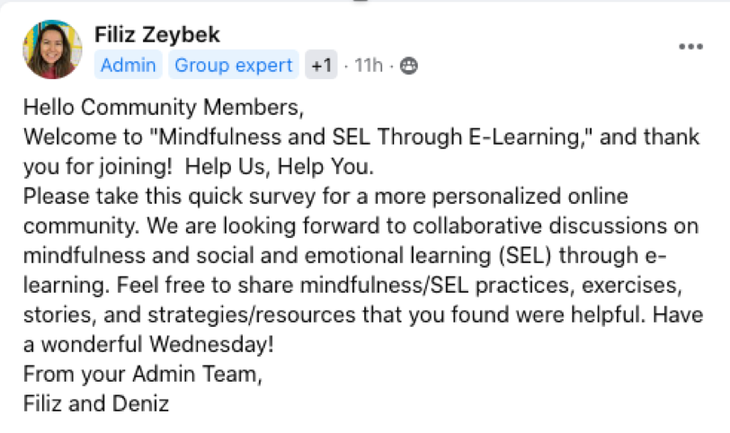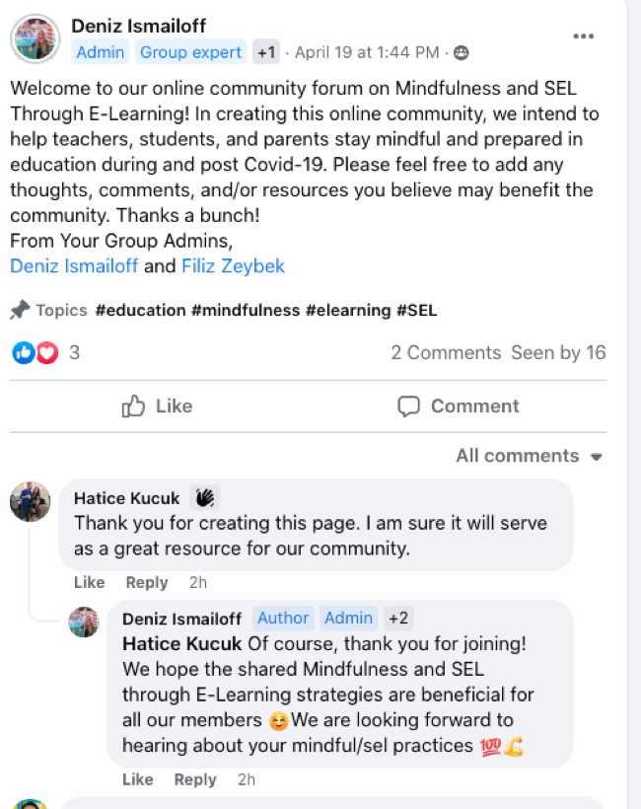

**Introductory**

**Member Survey**

