Dr. Shamburg,

I hope you are well. I wanted to inform you that I tried completing the “skip logic” step in the beginning of the survey, but the free trial option does not have a “skip logic” option or maybe there is another way? I googled but it did not give any.

Please see the skip option you display on your video

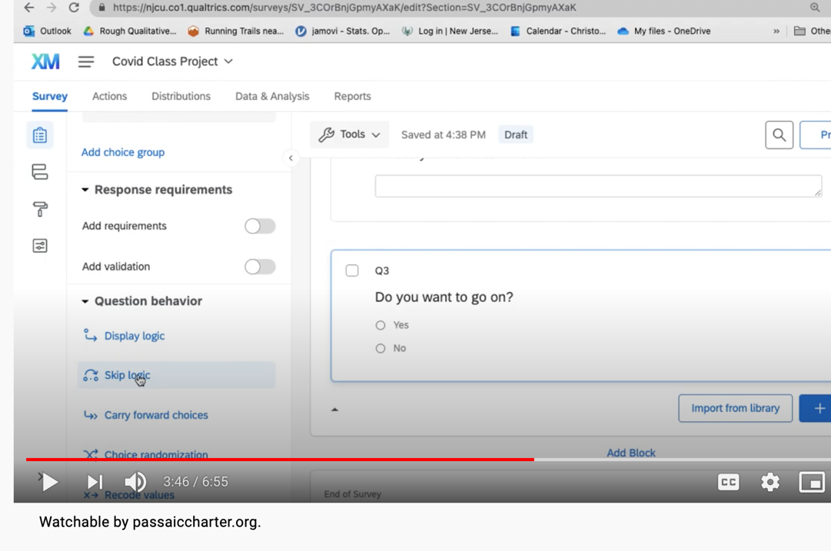

However, the version I have looks like this and does not have skip logic

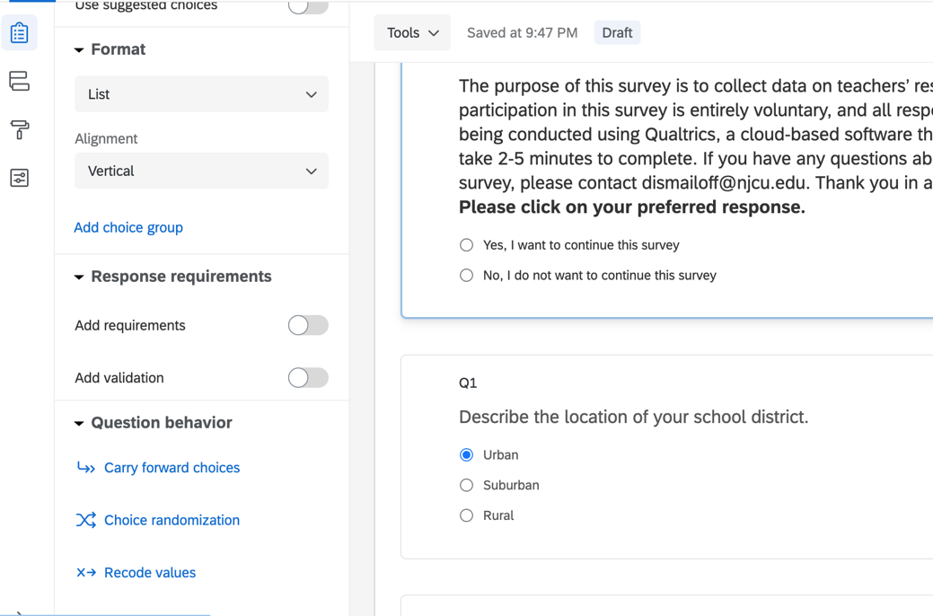

Lastly, I tried to go back to edit after publishing but it did not allow me to. Is there a way to edit again after publishing? I wanted to inform you that I noticed the extra line of choice bubbles (screen shot below) but I can’t figure how to go back and erase after publishing.

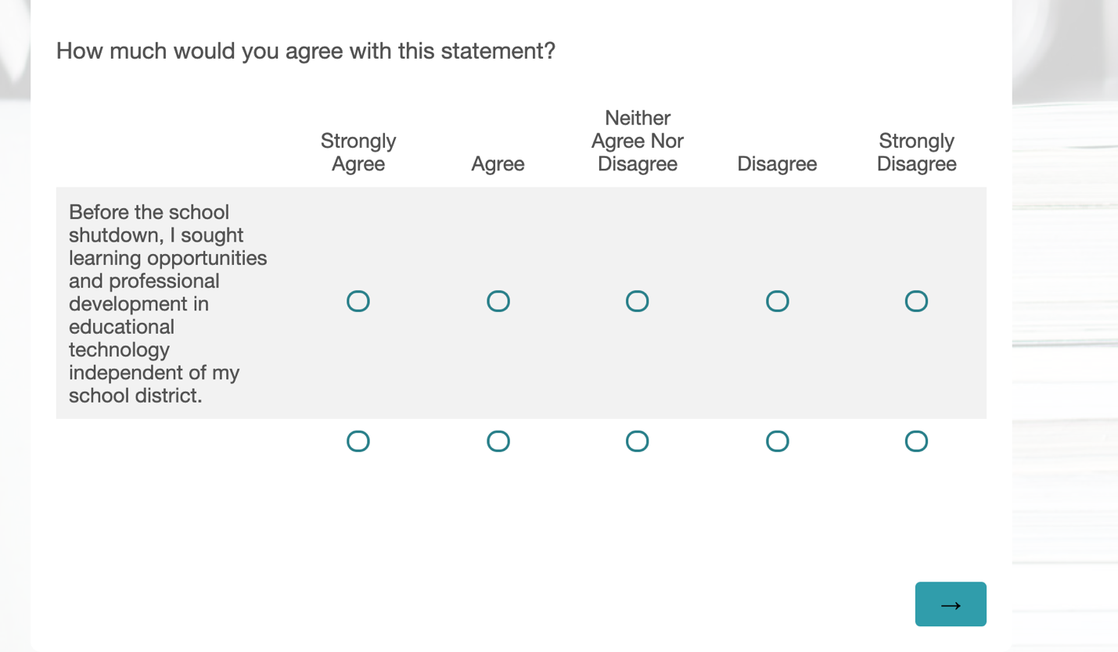

In looking at the prices for a Qualtrics subscription it costs about 390 for the standard subscription for 1 year. Are we going to be utilizing Qualtrics a lot this year? If so I will purchase it. If not, I will continue using the trial version. Below is the link to my survey. Note: it will be missing the section in the beginning where if the individual hits “No, he or she does not want to continue with the survey”, it will bring them to the end of the survey. Please let me know what to do moving forward as I do not want to get penalized for missing any steps. Thanks a bunch for your continuous support!

[Qualtrics link for Assessment 3- Permission Form and Survey Assignment](https://qfreeaccountssjc1.az1.qualtrics.com/jfe/form/SV_87Cu48P3UXReueG)

Best Regards,

Deniz Ismailoff