**Assignment 1- Observational Exercise: The Behavior of Individuals Studying at Panera Bread**

Deniz Ismailoff

New Jersey City University

EDTC 809: Assessment and Evaluation

Dr. Christopher Carnahan

October 18, 2021

The Behavior of Individuals Studying at Panera Bread

**Observational Exercise**

An essential aspect of qualitative studies is observation. Marshall (2014) describes observation as field notes, or observational records that are objective, detailed, and concrete. Observational field notes are vital for an ethnographic study because they include a methodical description of events, behaviors, and interactions between subjects within a specified environment (Emerson et al., 2011). Emerson et al. (2011) also emphasize the core of ethnographic research to be the first-hand participation in a natural unfamiliar social environment and the creation of written notes of that environment. Two questions guided the ethnographic field notes for this observational exercise:

1. How do subjects sitting alone study at Panera Bread?

* What is the time frame that the subject stays to study at Panera Bread?
* What is the subject eating or drinking while studying?

2. How do subjects with multiple individuals’ study while sitting at Panera Bread?

* What is the time frame that the subjects stay to study at Panera Bread?
* What are the subjects eating or drinking while studying?

**Ethnographic Fieldnotes**

An observation was conducted at Panera Bread in Montclair, New Jersey, on Thursday, October 7, 2021. The observation occurred on a Thursday afternoon from 3:30 pm-4:45 pm. The restaurant offered plenty of open space to have subjects talk and eat or study in a quiet space while snacking. The ambiance inside was calm with dimmed lights and light 1980's music playing in the background while the climate was cool and crisp. Images of the researcher's location can be found in Appendix A. After entering both double doors, the restaurant is divided into left and right dining areas, and each dining area has a large wall to the wall glass window with dining tables. The right side of the dining area had its ordering section and an island area with hot beverages and a microwave that separated the right and left sides of the dining room.

The researcher sat at a small table at the left side of Panera Bread's entrance. Upon entrance, the restaurant was quite empty on both the right and left sides of the dining area, and the backside had a few subjects sitting. To observe a broad range of subjects studying for one hour, the researcher grabbed a sandwich and soup and jotted notes. The focus of the observation was centered at the front left side of Panera Bread.

Throughout the observation, two female teenagers were sitting and eating salads on a table for four. One female had a book out and was highlighting as she read. The other female was on her computer typing. The girls' interaction was minimal while they ate and studied. Their studying lasted approximately 30 minutes. Two tables away, against the window, was an older man working diligently on his computer. He had papers on the table, and seemed as if he was utilizing the papers to add information to what he was typing. The older man was drinking a medium-hot beverage and eating a chocolate croissant. His face seemed focused and tense. A duration of time was not accounted for as the subject was still present after the researcher left.

Four teenage boys were sitting against the back of the front left dining area, parallel to the researcher. Two boys went to order as the other two emptied their belongings from their bookbags. The two boys returned with sandwiches, soups, chips, and drinks. They ate first while chatting and laughing and then began to do their work. The four boys were all on their laptops typing, talking, and laughing periodically. The subjects around the boys did not seem to be bothered by their noise. One of the subjects kept texting on his phone and was not interested in his work. The rest of the boys enjoyed their time while working and left telling jokes and laughing. The duration of their studying was approximately 20 minutes.

On the right side of the researcher by the hot beverage island was a woman in her 40’s with a little boy eating. The woman and boy were not studying; thus, the researcher did not focus on these participants. Within the last 20 minutes of the observation, two male subjects around their 20's were sitting adjacent at a small booth while working on their laptops with earphones on. The boys did not talk much and seemed focused on the task at hand. One of the boys had a sandwich with soup, while the other boy had a large hot beverage with a brownie and chocolate chip cookie. The subjects were packing up and speaking as the researcher left the premises.

**Observational Analysis**

Being a frequenter of Panera Bread, the researcher kept in mind the avoidance of interactions for minimal bias. The researcher also went to the establishment during an unfamiliar time, with the notion that it would be less crowded due to being a weekday and directly after school hours. Keeping the focus of the observation to the front left side of the entrance, the researcher had a range of different sized tables to examine. The researcher's analysis attempts to answer the research questions by identifying similarities, differences, and emerging themes. The ethnographic field notes centered on subjects' behavior studying while sitting at Panera Bread and sub-questions of subjects' food choice and duration of studying.

Themes emerged based on the observation notes to answer the research questions. 11 customers were observed for one hour. The observation notes reported three females and eight males entering Panera Bread in Montclair, New Jersey, on Thursday, October 7, 2021, from 3:45 pm-4:45 pm. Two females were teenagers, and one female was in her middle 40’s. Out of the eight males, one was a little boy, four were teenagers, two were in their middle 20’s, and one was an older gentleman. All 11 subjects were eating either a savory or sweet dish and drinking either a hot or cold beverage. Out of the 11 subjects, nine of them were studying while eating. Out of the nine subjects studying, only five were focused and on task. Subjects there to study, whether alone or with a group, stayed for 30 minutes or longer. Of the nine subjects, only one came to study alone. In short, regardless of being alone or with a group, all nine subjects observed studying at Panera Bread ate, were not bothered by others around them, and stayed for 30 minutes or longer.

**References**

Emerson, R. M., Fretz, R. I., & Shaw, L. L. (2011). *Writing ethnographic fieldnotes* (2nd ed.).

The University of Chicago Press.

Marshall, C., & Rossman, G. B. (2014). *Designing qualitative research*. Sage publications.

**Appendix A**

Images of Setting

**Figure 1**

*Front of Panera Bread, 15 Bloomfield Ave. Montclair, NJ 07042*

****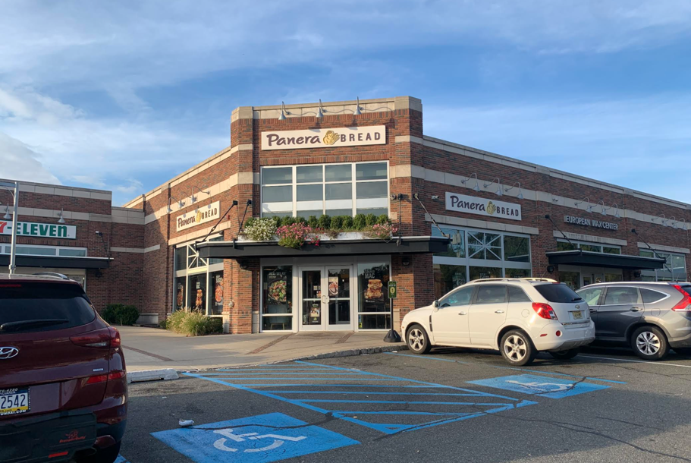

**Figure 2 Figure 3**

**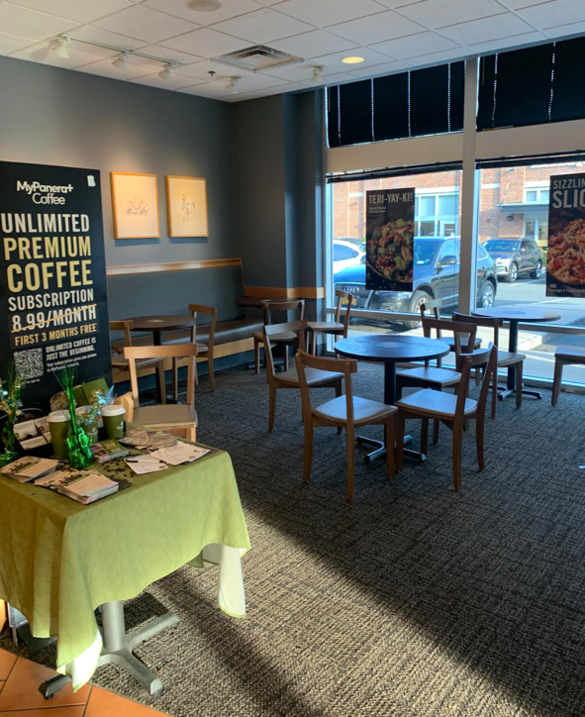***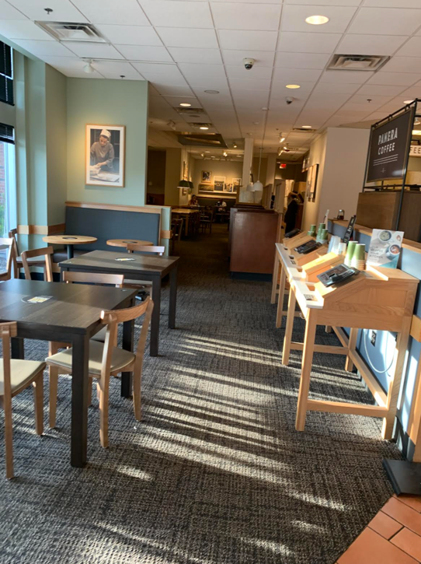Front left side of Panera Bread****** Front right side of Panera Bread*

